**SL Unit 3** **– Networks**  
Test 1

1. A wireless local area network (WLAN) is used to extend access to a school’s wired

local area network.

1. Identify **one** hardware component of the WLAN, other than computers. [1]

The advantages of this WLAN are user-mobility and economical access points.

1. Outline **two** disadvantages of this WLAN. [4]

1. Identify **three** ways in which the network administrator can reduce the risk of   
   unauthorized access to confidential data. [3]

The concept of packet data transmission is used within this network. Figure 1 shows the   
 simplified structure of a data packet.

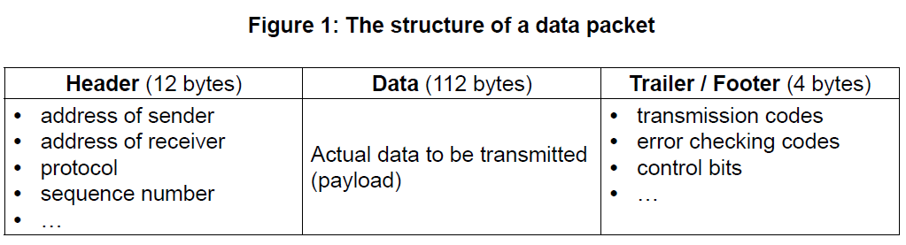

1. Define the term protocol. [1]
2. With reference to **Figure 1**, explain how data is transferred by packet switching. [6]

1. Outline the features of a virtual private network (VPN). [2]